**Lab 13**

Task 1 Source Code

import java.io.*;

import java.util.*;

public class task1 {

public static void main(String args[]) {

// Variable declarations: EXTRA CREDIT

int Quarter = 0;

int Dime = 0;

int Nickel = 0;

int Penny = 0;

Scanner userInput = new Scanner(System.in);

System.out.print("Enter a number between 0 and 99:> ");

int cents = userInput.nextInt();

do {

if (cents >= 25) {

System.out.println("Quarter");

Quarter += 1;

cents -= 25;

} else if (cents >= 10) {

System.out.println("Dime");

Dime += 1;

cents -= 10;

} else if (cents >= 5) {

System.out.println("Nickel");

Nickel += 1;

cents -= 5;

} else {

System.out.println("Penny");

Penny += 1;

cents -= 1;

}

} while (cents > 0);

// EXTRA CREDIT:

System.out.println();

System.out.println(" Quarters: " + Quarter);

System.out.println(" Dimes: " + Dime);

System.out.println(" Nickels: " + Nickel);

System.out.println(" Pennies: " + Penny);

}

}

/* TEST PLAN: TASK 1

TASK1.JAVA COMPILES WITHOUT ERRORS: [Y]

USER IS ASKED TO ENTER A NUMBER 0-99 [Y]

USER ENTERS 43,

EXPECTED: QUARTER, DIME, NICKEL, PENNY, PENNY, PENNY [Y]

USER ENTERS 9,

EXPECTED: NICKEL, PENNY, PENNY, PENNY, PENNY [Y]

USER ENTERS 1, EXPECTED: PENNY [Y]

USER ENTERS -12, EXPECTED: NULL RESPONSE [N] (Prints "Penny" and terminates.)

USER ENTERS "TWELVE", EXPECTED: NULL RESPONSE [N] (Exception in thread "main")

USER ENTERS .1, EXPECTED: NULL RESPONSE [N] (Exception in thread "main")

PROGRAM EXITS WITHOUT ERRORS: [Y] (Except when -12, "TWELVE" or .1 is entered)

*/

Task 1 Screenshot

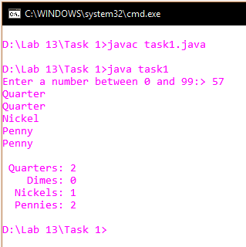

Task 2 Source Code:

import java.util.*;

public class task2 {

// Variable declarations (EXTRA CREDIT)

static int Benjamin = 0;

static int Fifty = 0;

static int Twenty = 0;

static int Ten = 0;

static int Five = 0;

static int One = 0;

static int Quarter = 0;

static int Dime = 0;

static int Nickel = 0;

static int Penny = 0;

public static void makeChange(double cash) { // Method for actually figuring out the change

System.out.println();

cash *= 100;

do {

if (cash >= 10000) {

System.out.println("$100 Bill");

Benjamin += 1;

cash -= 10000;

} else if (cash >= 5000) {

System.out.println("$50 Bill");

Fifty += 1;

cash -= 5000;

} else if (cash >= 2000) {

System.out.println("$20 Bill");

Twenty += 1;

cash -= 2000;

} else if (cash >= 1000) {

System.out.println("$10 Bill");

Ten += 1;

cash -= 1000;

} else if (cash >= 500) {

System.out.println("$5 Bill");

Five += 1;

cash -= 500;

} else if (cash >= 100) {

System.out.println("$1 Bill");

One += 1;

cash -= 100;

} else if (cash >= 25) {

System.out.println("Quarter");

Quarter += 1;

cash -= 25;

} else if (cash >= 10) {

System.out.println("Dime");

Dime += 1;

cash -= 10;

} else if (cash >= 5) {

System.out.println("Nickel");

Nickel += 1;

cash -= 5;

} else if (cash >= 1) {

System.out.println("Penny");

Penny += 1;

cash -= 1;

}

} while (cash > 0);

// Print how many of each denomination for extra credit:

System.out.println("\n" + "-=-=-=- BILLS -=-=-=-");

System.out.println(" Benjamins: " + "\t" + Benjamin);

System.out.println(" Fifties: " + "\t" + Fifty);

System.out.println(" Twenties: " + "\t" + Twenty);

System.out.println(" Tens: " + "\t" + Ten);

System.out.println(" Fives: " + "\t" + Five);

System.out.println(" Ones: " + "\t" + One);

System.out.println("\n" + "-=-=-=- COINS -=-=-=-");

System.out.println(" Quarters: " + "\t" + Quarter);

System.out.println(" Dimes: " + "\t" + Dime);

System.out.println(" Nickels: " + "\t" + Nickel);

System.out.println(" Pennies: " + "\t" + Penny);

}

public static void main(String[] args) {

Scanner userInput = new Scanner(System.in);

System.out.print("Enter a number from 0.01 to 999.99: ");

makeChange(userInput.nextDouble());

System.out.println();

}

}

/* TEST PLAN: TASK 2

TASK2.JAVA COMPILES WITHOUT ERRORS: [Y]

USER IS ASKED TO ENTER A NUMBER .01-9999.99: [Y]

USER ENTERS .15, AND PROGRAM DOES NOT HANG: [Y]

USER ENTERS .43,

EXPECTED: QUARTER, DIME, NICKEL, PENNY, PENNY, PENNY [Y]

USER ENTERS .09,

EXPECTED: NICKEL, PENNY, PENNY, PENNY, PENNY [Y]

USER ENTERS 1, EXPECTED: $1 BILL [Y]

USER ENTERS 234.64, EXPECTED:

$100 BILL

$100 BILL

$20 BILL

$10 BILL

$1 BILL

$1 BILL

$1 BILL

$1 BILL

QUARTER

QUARTER

DIME

PENNY

PENNY

PENNY

PENNY [Y]

USER ENTERS -12, EXPECTED: NULL RESPONSE [Y]

USER ENTERS -12.02, EXPECTED: NULL RESPONSE [Y]

USER ENTERS "TWELVE", EXPECTED: NULL RESPONSE [N] (Exception in thread "main")

USER ENTERS .1, EXPECTED: DIME [Y]

PROGRAM EXITS WITHOUT ERRORS: [Y]

EARNED EXTRA CREDIT: [HOPEFULLY]

*/

Task 2 Screenshot:

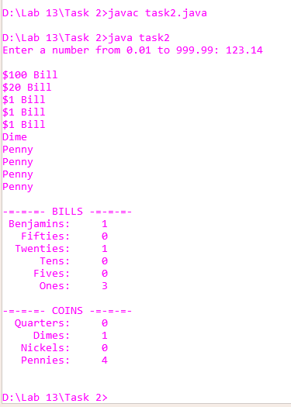

Task 3 Source Code:

public class task3 {

public static void main(String args[]) {

int bittage = 128;

while (bittage > 0) {

System.out.println(bittage);

bittage /= 2;

}

}

}

/* TEST PLAN: TASK 3

TASK3.JAVA COMPILES WITHOUT ERRORS: [y]

CONSOLE PRINTS 128: [y]

CONSOLE PRINTS 64: [y]

CONSOLE PRINTS 32: [y]

CONSOLE PRINTS 16: [y]

CONSOLE PRINTS 8: [y]

CONSOLE PRINTS 4: [y]

CONSOLE PRINTS 2: [y]

CONSOLE PRINTS 1: [y]

PROGRAM EXITS WITHOUIT ERRORS [y]

*/

Task 3 Screenshot:

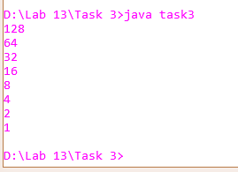

Task 4 Source Code:

import java.io.*;

import java.util.*;

public class task4 {

public static void main(String[] args) {

Scanner userInput = new Scanner(System.in);

System.out.println("This program converts a base-10 number into a base-2 number.");

System.out.print("Enter a base-10 number from 0 to 127:> ");

int baseTen = userInput.nextInt();

//int currentBit = 128;

String baseTwo = "";

do {

if (baseTen >= 128) {

baseTwo = baseTwo + "1";

baseTen -= 128;

} else {

baseTwo = baseTwo + "0";

}

if (baseTen >= 64) {

baseTwo = baseTwo + "1";

baseTen -= 64;

} else {

baseTwo = baseTwo + "0";

}

if (baseTen >= 32) {

baseTwo = baseTwo + "1";

baseTen -= 32;

} else {

baseTwo = baseTwo + "0";

}

if (baseTen >= 16) {

baseTwo = baseTwo + "1";

baseTen -= 16;

} else {

baseTwo = baseTwo + "0";

}

if (baseTen >= 8) {

baseTwo = baseTwo + "1";

baseTen -= 8;

} else {

baseTwo = baseTwo + "0";

}

if (baseTen >= 4) {

baseTwo = baseTwo + "1";

baseTen -= 4;

} else {

baseTwo = baseTwo + "0";

}

if (baseTen >= 2) {

baseTwo = baseTwo + "1";

baseTen -= 2;

} else {

baseTwo = baseTwo + "0";

}

if (baseTen >= 1) {

baseTwo = baseTwo + "1";

baseTen -= 1;

} else {

baseTwo = baseTwo + "0";

}

} while (baseTen > 0);

System.out.println(baseTwo);

}

}

/* TEST PLAN: TASK 4

PROGRAM COMPILES WITHOUT ERRORS: [y]

USER ENTERS 0, EXPECTED: '00000000' [y]

USER ENTERS 10, EXPECTED: '00001010' [y]

USER ENTERS 23, EXPECTED: '

USER ENTERS 98, EXPECTED: '

USER ENTERS 113, EXPECTED: '

USER ENTERS 126, EXPECTED: '

*/

Task 4 Screenshot:

